**MONGO DB CONFIGURATION IN PRODUCTION SERVER**

**Note:** The configuration has been done using Droplets, the server provider **Digital Ocean** with the version of **MongoDB 4.4** and a version of **Centos RHEL 8**.

1. **Configure the package management system (yum).**

Create a file /etc/yum.repos.d/mongodb-org-4.4.repo so that you can install MongoDB directly using yum:

Paste the following into the created file:

**[mongodb-org-4.4]**

name=MongoDB Repository

baseurl=https://repo.mongodb.org/yum/redhat/$releasever/mongodb-org/4.4/x86_64/

gpgcheck=1

enabled=1

gpgkey=https://www.mongodb.org/static/pgp/server-4.4.asc

1. **After saving the file we execute:**

sudo yum update

1. **Followed by this execute:**

sudo yum install -y mongodb-org

1. **We label the port that we are going to use for mongo, it is recommended not to use the default port for security for this example we will use port 27064.**

sudo semanage port -a -t mongod_port_t -p tcp 27064

1. **We add permissions to the firewall on the port to be used:**

sudo firewall-cmd --add-port = 27064 / tcp --permanent

sudo firewall-cmd --reload

1. **You can also limit access based on the source IP address:**

sudo firewall-cmd --permanent --add-rich-rule "rule family="ipv4" \

source address="ip_addres" port protocol="tcp" port="27064" accept"

1. **We enable access outside the server**

We edit the file /etc/mongod.conf which should look like this:

**Note:** What is marked with red color is what has to be added to the file.

systemLog:

destination: file

logAppend: true

path: /var/log/mongodb/mongod.log

# Where and how to store data.

storage:

dbPath: /var/lib/mongo

journal:

enabled: true

# engine:

# wiredTiger:

# how the process runs

processManagement:

fork: true # fork and run in background

pidFilePath: /var/run/mongodb/mongod.pid # location of pidfile

timeZoneInfo: /usr/share/zoneinfo

# network interfaces

net:

port: 27087

bindIp: 127.0.0.1 **,here_your_server_ip_address**

**security:**

**authorization: enabled**

1. **Reload deamon**

systemctl daemon-reload

1. **Start and enable mongo database:**

systemctl start mongod

systemctl enable mongod

1. **Creation of global user with authentication restrictions by ip**

We enter the mongo db console:

$ mongo

We enter the admin base to create the user:

> use admin

**Note:** The following operation creates a user. This user can only authenticate if he connects from one IP address XXX.X.X.X to another ZZZ.ZZ.ZZZ.Z

db.createUser({user: "your_user", pwd: "your_password", roles: [{role: "root", db: "admin"}],authenticationRestrictions:[{clientSource:[ " XXX.X.X.X ","add_other_ip" ],serverAddress:[ " ZZZ.ZZ.ZZZ.Z" ]}]})

1. **We will create a user for a specific database for security.**

First we go to the database that we want to create the user:

> use nueva_base

Then we create the user with the access restrictions by ip, roles and database to which it will belong:

db.createUser({user: "your_user", pwd: "your_password", roles: [{role: "readWrite", db: "nueva_base"}],authenticationRestrictions:[{clientSource:[ " XXX.X.X.X ","add_other_ip" ],serverAddress:[ " ZZZ.ZZ.ZZZ.Z" ]}]})

1. **We restart Mongo**

$ systemctl restart mongod

1. **We add Security by the Digital Ocean server as follows:**

We create some firewall rules as follows:

We enter the Droplet and click on Networking:

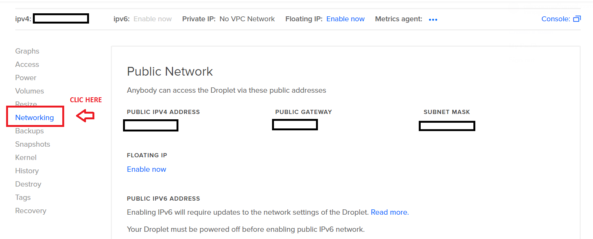

We have a section on Firewalls, we create firewall rules and enter the rules you need for your server, in this case the basic ones were added and in the blank spaces of the image the IP allowed to access your server should be included and how such to the database through the previously configured port:

